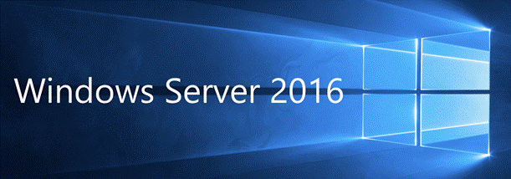

Windows Server 2016 is a Cloud-ready operating system, which introduced technologies for an easy transition to Cloud computing and adding new layers of security to secure your organization’s infrastructure.

**What’s** **new** **with** **Windows** **Server** **2016?**  
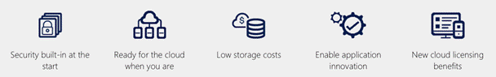

1. *Built-in Security (OS level) - Adding layers of Security*

Windows Server 2016 comes with the built-in breach resistance to help to prevent the attacks on the computers. Even if a hacker enters into your environment, these layers of security built in Windows Server 2016 limits the damage; the hacker can cause and help to detect a suspicious activity.

Windows Server 2016 provides security at the operating system level. Following are the various beneﬁts with these added layers of security in Windows Server 2016.

* 1. Protect VMs (Virtual Machines). b. Secure Administrator Credintials. c. Helps to identify the attacks.
  2. Meet compliance goals.
  3. Protects operating system.

1. *Migrate to Cloud when you are ready*You can now easily migrate to Cloud with Hyper-V.
2. *Low Storage Costs*You can get affordable storage costs and high performance with the software-deﬁned storage capabilities in Windows Server 2016.
3. *Application Innovation*You can run your existing Applications on Windows Server 2016 without modifying them. With modern DevOps environment, you can easily transform the way; you develop, run and deploy.
4. *New Cloud Licensing Beneﬁts*With Azure Hybrid use beneﬁt, you can save up to 50 percent on Windows Server virtual machines.

**Windows** **Server** **2016** **Editions**

There are two editions of Windows Server 2016. They are listed below.

1. *Windows Server 2016 Standard*
   1. Standard edition is limited to 16 or few processor cores. With this edition, you can host up to 2 virtual machines in Hyper- V.
   2. This edition is for physical or minimally virtualized environments.
2. *Windows Server 2016 Data Center Edition*
   1. There is no software limitation in Data Center Edition. It can host unlimited virtual machines. This edition is for highly virtualized or Cloud environments.
   2. This edition includes new Data Center functionality.
   3. Shielded VMs.
   4. Software deﬁned storage and networking.

**Other** **Editions** **of** **Windows** **Server** **2016**

There are other editions as well of Windows Server 2016 for special use and they are given below.

* *Essential Edition*It is for small business that never grows beyond 25 - 50 devices.
* *Nano Server*It is a feature, which comes with Standard or Data Center Edition. It can be a ﬁle Server, Web Server or Smart Virtual Machine or DHCP/DNS etc.
* *Hyper -V (Hypervisor)*Hyper-V hosts other virtual machines.